UNIT-I ACD

Basic Terminology
Computation:

Computation can be defined as finding solution to a problem from given inputs by means of algorithm.

The theory of computation, a subfield of computer science and mathematics, deals with finding solutions to problems from the given inputs.

Symbols:

A symbol is a single object and is an abstract entity that has no meaning by itself. It can be character. Normally, characters from a typical keyboard are used as symbols.

Example: A, a, (alpha), (Lambda), etc..

Alphabets:

An alphabet is any finite, non-empty set of symbols/ characters.
Example:

- = {0, 1} is the binary alphabet, consisting of the symbols 0 and 1.

- = {a, b, c} is an alphabet of three symbols.

- = {A, B,………, Z} is the uppercase English alphabet.

Strings:

A string is a finite sequence of symbols chosen from some alphabet. In other words, a string is a finite sequence of symbols over an alphabet. It is usually denoted by W or S.

Example:

- If = {0, 1} then 01010, 1111, 11, 11, 10, 01… are some of the strings chosen from this alphabet.

b. If = {a, b} then ab, abab, aabb, are the words chosen from this alphabet.

Automaton:

An automaton (plural: automata) is a self-operating machine. The term "Automata" is derived from the Greek word "αὐτόματα" which means "self-acting" or self-operational. It performs its functions without direct human participation. It is self-operational.

  - FORMAL LANGUAGES
- A formal language is an abstraction for general characteristics of programming languages

that can be defined as a string set, all of which are chosen from some particular alphabet .

- A formal language is a set of finite length words drawn from some finite alphabet.
- The languages are denoted by letter L, with or without a subscript.

- L(M) is a language defined by a machine M, that accepts a certain set of strings.

- L (G) is a language defined by grammar G that accepts a certain string set.

- L(r) is a language defined by a regular expression ‘r’.

a. Let ={Z} then the language of all possible strings is given by L1= {z, zz, zzz, zzzz,…}. Here L1 does not contain null string. b. Language containing the null string is { }

- Null language: { } = .
Operations on languages:

 | There are totally 10 operations on languages. They are:
1. |  | Union |  | 6. | Reversal of languages
2. |  | Intersection |  | 7. | Palindrome languages
3. |  | Complementation |  | 8. | Length sub-setting of a language
4. |  | Symmetric difference |  | 9. | Kleene star/closure of languages
5. |  | Concatenation of language |  | 10. | De Morgan’s Laws.
 |  |  |  |  | 1

UNIT-I ACD

- Union :
This is one of the simplest operation on two languages. As discussed earlier languages are set of

strings, and hence the union of two languages L₁ and L₂ is the set L₁UL₂. Mathematically, this is represented as X L₁UL₂, if and only if x L₁ or x L₂
Example
a. Let L₁={0,01,011} and L₂={011}
then L₁ U L₂ = { 0,01,011}

b. Let L₁={0,000,00000,…} and L₂={ ,00,0000,…} then L₁ U L₂ = {0}*

- Intersection :
Suppose L₁ and L₂ are two languages over an alphabet .Then intersection of L₁ and L₂ is denoted by L₁ L₂, if and only if x L₁ and x L₂.
Example
a. Let L₁={ } and L₂= .Then L₁ |  | L₂=
b. Let L be any language, then L |  | L’= .

- Complementation :

It is an operation performed on a single language. Suppose L is a language over an alphabet , then the compliment of L, denoted by L’, is the language consisiting of all those strings that are not

in L over the alphabet. Mathematically, this is expressed as x L’ if and only if x * - L

a. If ={a,b} and L={a,b,aa} then the complement of L i.e., L’= *-L =

{ ,a,b,aa,bb,ab,ba,aaa,bbb,……}-{a,b,aa} = { , bb, ab, ba…}

  - Let L= { , 1, 11…} be a language over {0, 1}. Then, clearly L’ consists of all strings, containing at least one 0.

- Symmetric difference :
The operation, symmetric difference is no doubt an important but less
familiaroperation.Suppose,L₁ and L₂ are two languages defined over an |  |  |  | alphabet .Then the
symmetric difference of L₁ and L₂ is denoted by L₁ L₂,and |  |  | is defined as L₂ |  | L₂=(L1
 | Accordingly, elements of L₁ L₂ are contained either in L₁ or L₂ but not in both.
 | Example:
 | a. Let L be a language over an alphabet .Then clearly L |  | =L, L L= | , L | * = L’ and
 | LL’=*
 | b. Let L₁= {00, 0000,..} and L₂= {11, 1111,..}.Then , L₁ |  | L₂= {00, 11, 0000, 1111,…}
  - L₁ U L₂.
- Concatenation of languages :

Concatenation of two languages L₁ and L₂ is the language L₁ L₂, each element of which is a

string formed by gluing one string of L₁ with another string of L₂.Mathematically, this is expressed as: L L₂=L₁L₂= { y|x L₁ and y L₂}
Example:
  - Let L₁={bc,bcc,cc} and L₂={cc,ccc} then, L₁ L₂= {bccc, bcccc, bcccccc, cccc, ccccc}
  - Let L₁={zizz,…} and L₂={0,1} then, L₁ L₂={zzz,zzzzz,…}.
- Reversal of languages :
The reversal of a language is an important operation that can be used in illustrating the working

procedure of various machines. This operation is similar to the reversal of a string operation. Mathematically, this can be written as L^{R}= {W^{R}|W L}

- If L={ab,bc,cd} then, L^{R}= {ba, cb, dc}

- If L={10,12,34} then, L^{R}= {01, 21, 43}

2

UNIT-I ACD

7. Palindrome languages :

A language called Palindrome over = {a, b} is defined as:

Palindrome= { , all strings W, such that WR=W and W }.

- Length subsetting of a language :

Suppose L is a language over a fixed alphabet . Then for sake of convenience or compactness, it may be required to specify the strings in L, of length less than or equal to a specific value or a fixed size.
Example:
  - Let L={1,11,111,1111,…} then L⁼⁴= {1111} and L^{<=4} = {1, 11, 111, 1111}.
- Kleene star/Closure of languages :
The Kleene star of language L is the language L*, consisting of all the strings produced by

concatenating any finite number of strings from L, together. In other words, kleene star denotes the set of all words/strings of any length of any length from given language. Mathematically, this is expressed as L*= {X| 0X₁0X₂…0X_{R} , with R 0 and X_{R} L}
Example:
  - If L={ ,z,zz,zzz,…} over = {z} then L*= { , z, zz, zzz,…}, Where L*=L⁰ U L¹ U L²

U…

  - *={ }.

- De Morgan’s Laws :

It allows one to express the intersection of two languages over , in terms of the two operation
like, union and complementation. These are the fundamental laws in set theory.
Let L₁, L2, L3 be any three languages, then
L₁ . (L₂ L₃) = (L₁ . L₂) U (L₁ . L₃)
L₁ L₂ = (L₁^{C} U L₂^{C}) ^{C.}

2. REGULAR EXPRESSIONS

Certain set of strings or languages can be represented in an algebraic fashion, and these algebraic expressions of languages are called regular expression.

A regular expression is a string that describes the whole set of strings according to a certain syntax rule. These expressions are used by text editors and utilities, to search bodies of text for certain patterns.
A Regular Expression can be recursively defined as follows −

- ε is a Regular Expression indicates the language containing an empty string. (L (ε) = {ε})
- φ is a Regular Expression denoting an empty language. (L (φ) = { })
- x is a Regular Expression where L = {x}

- If X is a Regular Expression denoting the language L(X) and Y is a Regular Expression denoting the language L(Y), then

• X + Y is a Regular Expression corresponding to the language L(X) L(Y) where L(X+Y) = L(X) ∪L(Y).

  - X . Y is a Regular Expression corresponding to the language L(X) . L(Y) where

L(X.Y) = L(X) . L(Y)

  - R* is a Regular Expression corresponding to the language L(R*)where L(R*) = (L(R))*
- If we apply any of the rules several times from 1 to 5, they are Regular Expressions.

3

UNIT-I | ACD
Some RE Examples
Regular | Regular Set
Expressions | Regular Set
(0 + 10*) | L = { 0, 1, 10, 100, 1000, 10000, … }
(0*10*) | L = {1, 01, 10, 010, 0010, …}
(0 + ε)(1 + ε) | L = {ε, 0, 1, 01}
(a+b)* | Set of strings of a’s and b’s of any length including the null string. So L = { ε, a,
(a+b)* | b, aa , ab , bb , ba, aaa…….}
(a+b)*abb | Set of strings of a’s and b’s ending with the string abb. So L = {abb, aabb, babb,
(a+b)*abb | aaabb, ababb, …………..}
(11)* | Set consisting of even number of 1’s including empty string, So L= {ε, 11, 1111,
(11)* | 111111, ……….}
(aa)*(bb)*b | Set of strings consisting of even number of a’s followed by odd number of b’s ,
(aa)*(bb)*b | so L = {b, aab, aabbb, aabbbbb, aaaab, aaaabbb, …………..}
(aa + ab + ba + | String of a’s and b’s of even length can be obtained by concatenating any
bb)* | combination of the strings aa, ab, ba and bb including null, so L = {aa, ab, ba, bb,
bb)* | aaab, aaba, …………..}
Any set that represents the value of the Regular Expression is called a Regular Set.

Properties of Regular Sets:
Property1. The union of two regular set is regular.

Proof − Let us take two regular expressions
RE₁ = a(aa)* and RE₂ = (aa)*
So, L₁ = {a, aaa, aaaaa,.....} (Strings of odd length excluding Null)
and L₂ ={ ε, aa, aaaa, aaaaaa,.......} (Strings of even length including Null)
L_{1∪} L₂ = { ε, a, aa, aaa, aaaa, aaaaa, aaaaaa,.......}

(Strings of all possible lengths including Null)
RE (L₁∪L₂) = a* (which is a regular expression itself)

Hence, proved.
Property2. The intersection of two regular set is regular.
Proof −

Let us take two regular expressions
RE₁ = a(a*) and RE₂ = (aa)*
So, L₁ = { a,aa, aaa, aaaa, ....} (Strings of all possible lengths excluding Null)
L₂ = { ε, aa, aaaa, aaaaaa,.......} (Strings of even length including Null)
L₁ ∩ L₂ = { aa, aaaa, aaaaaa,.......} (Strings of even length excluding Null)
RE (L₁ ∩ L₂) = aa(aa)* which is a regular expression itself.

Hence, proved.
Property3. The complement of a regular set is regular.
Proof −

Let us take a regular expression −
RE = (aa)*

So, L = {ε, aa, aaaa, aaaaaa, .......} (Strings of even length including Null)
Complement of L is all the strings that is not in L.

So, L’ = {a, aaa, aaaaa, .....} (Strings of odd length excluding Null)
RE (L’) = a(aa)* which is a regular expression itself.

Hence, proved.

4

UNIT-I ACD

Property4. The difference of two regular set is regular.

Proof −
Let us take two regular expressions −
RE₁ = a (a*) and RE₂ = (aa)*
So, L₁ = {a, aa, aaa, aaaa, ....} (Strings of all possible lengths excluding Null)
L₂ = { ε, aa, aaaa, aaaaaa,.......} (Strings of even length including Null)
L₁ – L₂ = {a, aaa, aaaaa, aaaaaaa, ....}

(Strings of all odd lengths excluding Null)
RE (L₁ – L₂) = a (aa)* which is a regular expression.

Hence, proved.
Property 5. The reversal of a regular set is regular.
Proof −
We have to prove L^{R} is also regular if L is a regular set.
Let, L = {01, 10, 11, 10}

RE(L)=01+10+11+10
L^{R} = {10, 01, 11, 01}
RE (L^{R}) = 01 + 10 + 11 + 10 which is regular
Hence, proved.
Property 6. The closure of a regular set is regular.
Proof −

If L = {a, aaa, aaaaa, .......} (Strings of odd length excluding Null)
i.e., RE (L) = a (aa)*

L* = {a, aa, aaa, aaaa , aaaaa,……………} (Strings of all lengths excluding Null)
RE (L*) = a (a)*

Hence, proved. (also seen the Positive Closure) Property 7. The concatenation of two regular sets is regular.

Proof −
Let RE₁ = (0+1)*0 and RE₂ = 01(0+1)*
Here, L₁ = {0, 00, 10, 000, 010, ......} (Set of strings ending in 0)
and L₂ = {01, 010,011,.....} (Set of strings beginning with 01)
Then, L₁ L₂ = {001,0010,0011,0001,00010,00011,1001,10010,.............}

Set of strings containing 001 as a substring which can be represented by an RE − (0 + 1)*001(0 + 1)*

Hence, proved.

Identities Related to Regular Expressions:
Given R, P, L, Q as regular expressions, the following identities hold −

- φ* = ε
- ε* = ε
- RR* = R*R
- R*R* = R* = (R*)* = R*
- (PQ)*P =P(QP)*
- (a+b)* = (a*b*)* = (a*+b*)* = (a+b*)* = a*(ba*)*
- R + φ = φ + R = R (The identity for union)
- R ε = ε R = R (The identity for concatenation)

- φ L = L φ = φ (The annihilator for concatenation)
- R + R = R (Idempotent law)
- L (M + N) = LM + LN (Left distributive law)

- (M + N) L = ML + NL (Right distributive law)
- ε + RR* = ε + R*R = R*

5

UNIT-I ACD

3. FINITE AUTOMATA

An automaton with a finite number of states is called a Finite Automaton (FA) or Finite State Machine (FSM).

Components of Finite Automat

- Input - A string fed to a machine which the machine will determine whether it is part of the language or not? An input is read by a machine in a forward fashion, one symbol at a time.

- Return - The results of running the machine on a given input. Initially, this will either be accepted or rejected, indicating whether the input string is respectively part of the language or not.

- State - A resting place while the machine reads more input, if more input is available. States are typically named. State names must be unique. Graphically, states are represented by a circle with the name inside.

- Start State - It is the state that the machine naturally starts in before it reads any input. The name for the start state will usually either be S or q₀. Graphically, the start state is represented as a state with an unlabeled arrow pointing from nothing to it.

- Accepting State or Final State - A state or a set of states which the machine may halt in, provided it has no input left, in order to accept the string as part of the language. Graphically, accepting states are indicated using a double circle instead of a single.

- Rejecting State - Any state in the machine which is not denoted as an accepting state. The string is only rejected if the machine halts in a rejecting state with no more input left

- Dead State - A rejecting state that is essentially a dead end. Once the machine enters a dead state, there is no way for it to reach an accepting state.

- Transition - A way for a machine to go from one state to another given a symbol from the input. Graphically, a transition is represented as an arrow pointing from one state to another, labelled with the symbol or symbols that it can read in order to move the machine from the state at the tail of the arrow to the tip of the arrow. Transitions may even point back to the same state that they came from, which is called a loop.

Formal definition of a Finite Automaton
An automaton can be represented by a 5-tuple (Q, ∑, δ, q₀, F), where −
- Q is a finite set of states.
- ∑ is a finite set of symbols, called the alphabet of the automaton.
- δ is the transition function.
• q₀ is the initial state from where any input is processed (q_{0∈}Q).

- F is a set of final state/states of Q (F ⸦ Q).

Finite Automaton can be classified into two types – 1. Deterministic Finite Automaton (DFA), and 2. Non-deterministic Finite Automaton (NDFA / NFA)

Deterministic Finite Automaton (DFA)

In DFA, for each input symbol, one can determine the state to which the machine will move. Hence, it is called Deterministic Automaton. As it has a finite number of states, the machine is called Deterministic Finite Machine or Deterministic Finite Automaton.

Formal Definition of a DFA
A DFA can be represented by a 5-tuple (Q, ∑, δ, q₀, F) where −

- Q is a finite set of states.
- ∑ is a finite set of symbols called the alphabet.
- δ is the transition function where δ: Q × ∑ → Q
• q₀ is the initial state from where any input is processed (q₀ Q).

- F is a set of final state/states of Q (F ⸦ Q).

Graphical Representation of a DFA
A DFA is represented by digraphs called state diagram.

6

UNIT-I ACD

- The vertices represent the states.
- The arcs labelled with an input alphabet show the transitions.
- The initial state is denoted by an empty single incoming arc.

- The final state is indicated by double circles.

Example
Let a deterministic finite automaton be → Q = {a, b, c}, ∑ = {0, 1}, q₀ = {a}, F = {c}, and Transition function δ as shown by the following table −

Present State | Next State for Input 0 | Next State for Input 1
a | a | b
b | c | a
c | b | c
Its graphical representation would be as follows −
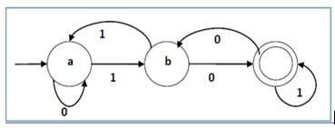

Non-deterministic Finite Automaton :

In NDFA, for a particular input symbol, the machine can move to any combination of the states in the machine. In other words, the exact state to which the machine moves cannot be determined. Hence, it is called Non-deterministic Automaton. As it has finite number of states, the machine is called Non-deterministic Finite Machine or Non-deterministic Finite Automaton.

Formal Definition of an NDFA
An NDFA can be represented by a 5-tuple (Q, ∑, δ, q₀, F) where −

- Q is a finite set of states.
- ∑ is a finite set of symbols called the alphabets.
- δ is the transition function where δ: Q × ∑ → 2^{Q}

(Here the power set of Q (2^{Q}) has been taken because in case of NDFA, from a state, transition can occur to any combination of Q states)
• q₀ is the initial state from where any input is processed (q₀ Q).
- F is a set of final state/states of Q (F ⸦ Q).

Graphical Representation of an NDFA: (same as DFA)
An NDFA is represented by digraphs called state diagram.
- The vertices represent the states.
- The arcs labelled with an input alphabet show the transitions.
- The initial state is denoted by an empty single incoming arc.
- The final state is indicated by double circles.

Example
Let a non-deterministic finite automaton be → Q = {a, b, c}, ∑ = {0, 1}, q₀ = {a}, F = {c} The transition function δ as shown below −

7

UNIT-I |  |  |  | ACD
 | Present State | Next State for Input 0 | Next State for Input 1
 | A | a, b | b
 | B | c | a, c
 | C | b, c | c
Its graphical representation would be as follows −
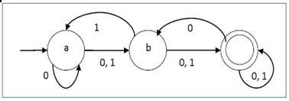

DFA vs NDFA
The following table lists the differences between DFA and NDFA.
DFA |  | NDFA
The transition from a state is to | a single | The transition from a state can be to multiple next
particular next state for each input | symbol. | states for each input symbol. Hence it is called
Hence it is called deterministic. |  | non-deterministic.
Empty string transitions are not seen in DFA. |  | NDFA permits empty string transitions.
Backtracking is allowed in DFA |  | In NDFA, backtracking is not always possible.
Requires more space. |  | Requires less space.
A string is accepted by a DFA, if it transits to a |  | A string is accepted by a NDFA, if at least one of
final state. |  | all possible transitions ends in a final state.

- CONVERTING A REGULAR EXPRESSION TO A NFA (THOMPSON'S ALGORITHM):
We will use the rules which defined a regular expression as a basis for the construction:
1. The NFA representing the empty string is:
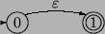

2. If the regular expression is just a character, eg. a, then the corresponding NFA is :
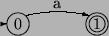

3. The union operator is represented by a choice of transitions from a node; thus a|b can be

represented as:
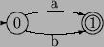

4. Concatenation simply involves connecting one NFA to the other; eg. ab is:
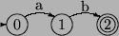

8

UNIT-I ACD

- The Kleene closure must allow for taking zero or more instances of the letter from the input; thus a* looks like:
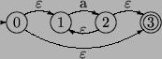

Example: Find NFA-Ԑ for regular expression (a+bb)*
- Consider NFA for ‘a’

Consider NFA for ‘b’

Consider NFA for ‘bb’
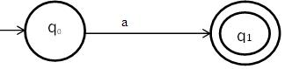
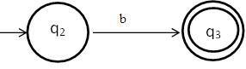
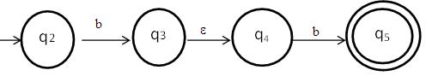

Consider NFA for ‘a+bb’
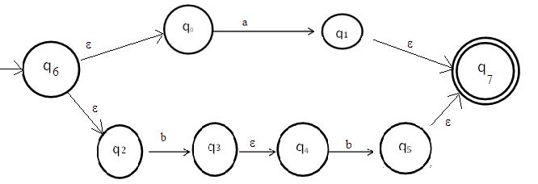

Consider NFA for ‘(a+bb)*’
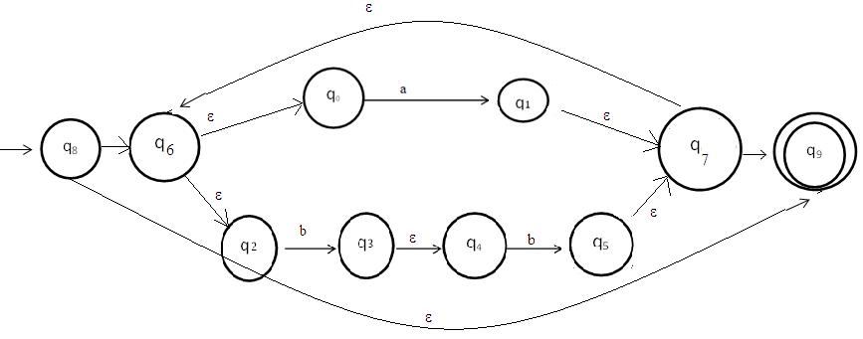

9

UNIT-I ACD

- NFA TO DFA CONVERSION
Problem Statement
Let X = (Q_{x}, ∑, δ_{x}, q₀, F_{x}) be an NDFA which accepts the language L(X). We have to design an equivalent DFA Y = (Q_{y}, ∑, δ_{y}, q ₀, F_{y}) such that L(Y) = L(X). The following procedure converts
the NDFA to its equivalent DFA −

Algorithm
Input − An NDFA
Output − An equivalent DFA

Step 1 − Create state table from the given NDFA.
Step 2 − Create a blank state table under possible input alphabets for the equivalent DFA.

Step 3 − Mark the start state of the DFA by q0 (Same as the NDFA).
Step 4 − Find out the combination of States {Q₀, Q₁,... , Q_{n}} for each possible input alphabet.

Step 5 − Each time we generate a new DFA state under the input alphabet columns, we have to apply step 4 again, otherwise go to step 6.

Step 6 − The states which contain any of the final states of the NDFA are the final states of the equivalent DFA.

Example
Let us consider the NDFA shown in the figure below.
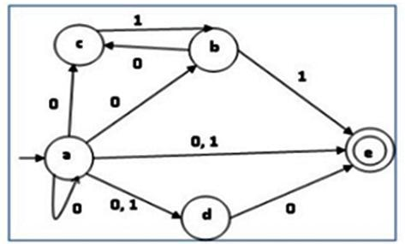

q | δ(q,0) | δ(q,1)
a | {a,b,c,d,e} | {d,e}
b | {c} | {e}
c | ф | {b}
d | {e} | ф
e | ф | ф

Using the above algorithm, we find its equivalent DFA. The state table of the DFA is shown in below.

 | q | δ (q,0) | δ (q,1)
 | a | {abcde} | {de}
 | abcde | {abcde} | {bde}
 | de | {e} | {f}
 | bde | {ce} | {e}
 | e | {f} | {f}
 | ce | {f} | {b}
 | b | {c} | {e}
 | c | {f} | {b}
 | f | {f} | {f}
 |  |  | 10

UNIT-I ACD

The state diagram of the DFA is as follows –
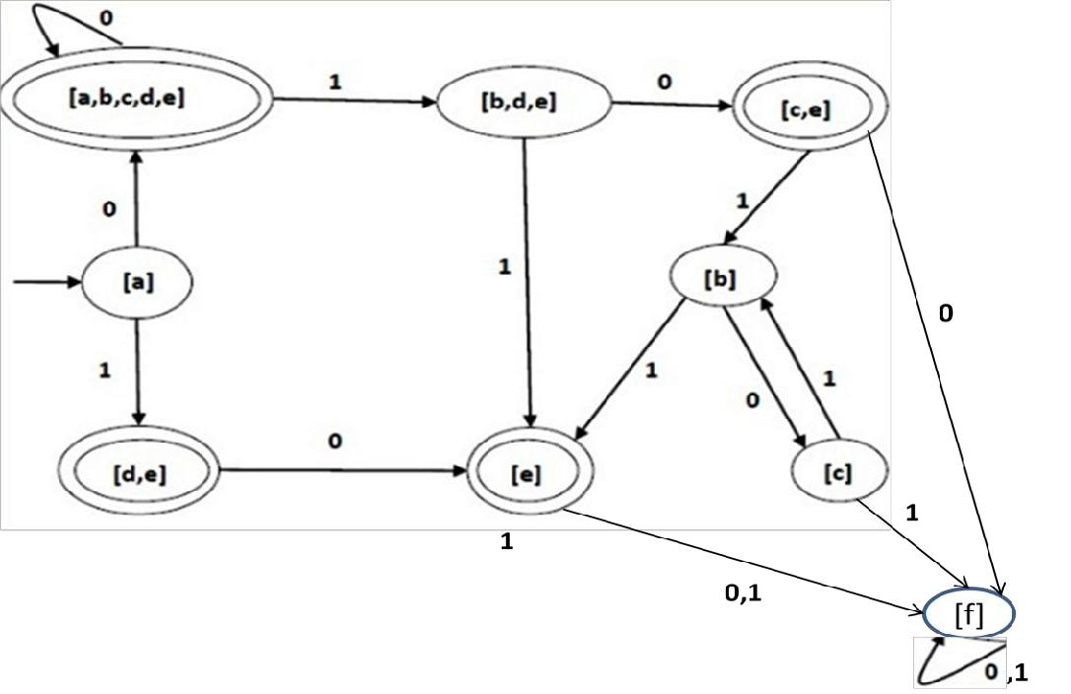

- APPLICATIONS OF FINITE AUTOMATA: Finite Automata have several applications.
  - A Finite Automata is highly useful in designing Lexical Analyzers.
  - A Finite Automata is highly useful in designing text editors.

  - A Finite Automata is highly useful in designing spell checkers.

  - A Finite Automata is highly useful in designing Sequential Circuit design (or) Hardware Design.

    - String processing.

Example:

- To find all occurrences of pattern 1001, construct the DFA for all strings ending in 1001.
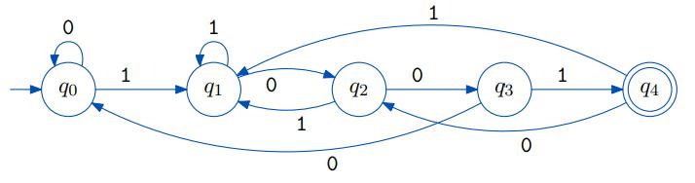

11

UNIT-I ACD

7. LEX TOOL

Lex is a program designed to generate scanners, also known as tokenizers, which recognize lexical patterns in text. Lex is an acronym that stands for "lexical analyzer generator." It is intended primarily for Unix-based systems.

Lex is a tool in lexical analysis phase to recognize tokens using regular expression. Lex tool itself is a lex compiler.

Use of Lex
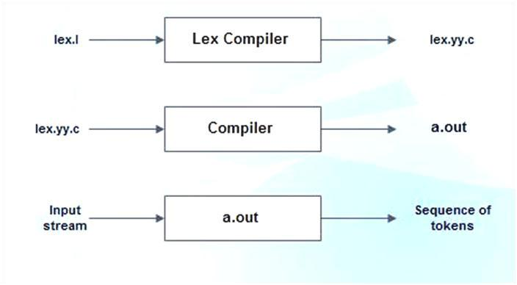

lex.l is an a input file written in a language which describes the generation of lexical analyzer. The lex compiler transforms lex.l to a C program known as lex.yy.c.

lex.yy.c is compiled by the C compiler to a file called a.out.

The output of C compiler is the working lexical analyzer which takes stream of input characters and produces a stream of tokens.

yylval is a global variable which is shared by lexical analyzer and parser to return the name and an attribute value of token.
The attribute value can be numeric code, pointer to symbol table or nothing.
Another tool for lexical analyzer generation is Flex.

Structure of Lex Programs
Lex program will be in following form

declarations
%%

translation rules
%%

auxiliary functions

Declarations This section includes declaration of variables, constants and regular definitions.
Translation rules It contains regular expressions and code segments.

Form: Pattern {Action}
Pattern is a regular expression or regular definition.

Action refers to segments of code.

Auxiliary functions This section holds additional functions which are used in actions. These functions are compiled separately and loaded with lexical analyzer.

Lexical analyzer produced by lex starts its process by reading one character at a time until a valid match for a pattern is found. Once a match is found, the associated action takes place to produce token. The token is then given to parser for further processing.

12

UNIT-I ACD

Example: Write a Lex program to perform Lexical analyzer functionality

delim [\t]

ws {delim}+
letter [A-Za-z]

digit [0-9]
id {letter}({letter}|{digit})*

num {digit}+(\.{digit}+)?(E[+-]?{digit}+)?
%%

ws {printf("no action");}

if|else|then {printf("%s is a keyword",yytext);} // TYPE 32 KEYWORDS {id} {printf("%s is a identifier",yytext);}
{num} {printf(" it is a number");}

"<" {printf("it is a relational operator less than");}

"<=" {printf("it is a relational operator less than or equal");} ">" {printf("it is a relational operator greater than");} ">=" {printf("it is a relational operator greater than");} "==" {printf("it is a relational operator equal");}
"<>" {printf("it is a relational operator not equal");}

%%
main()

{
yylex();

}
OUTPUT

lex lexicalfile.l

- lex.yy.c -ll
if

if is a keyword number

number is a identifier 254

It is a number <>

it is a relational operator not equal ^Z

13

